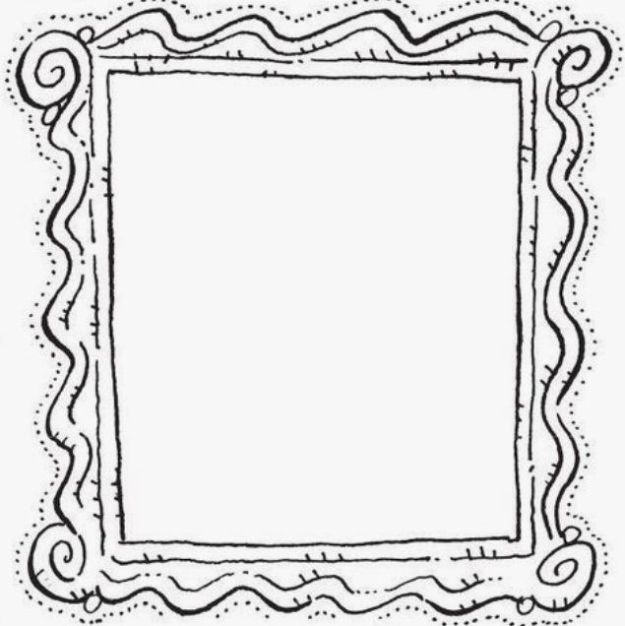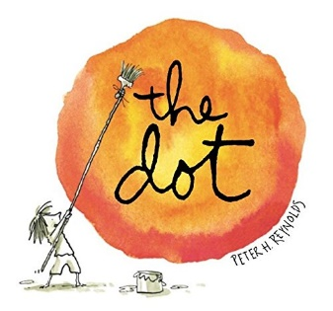

Cut out the frame, add your art, and hang it up to share!

Here’s a swirly frame for your creation!