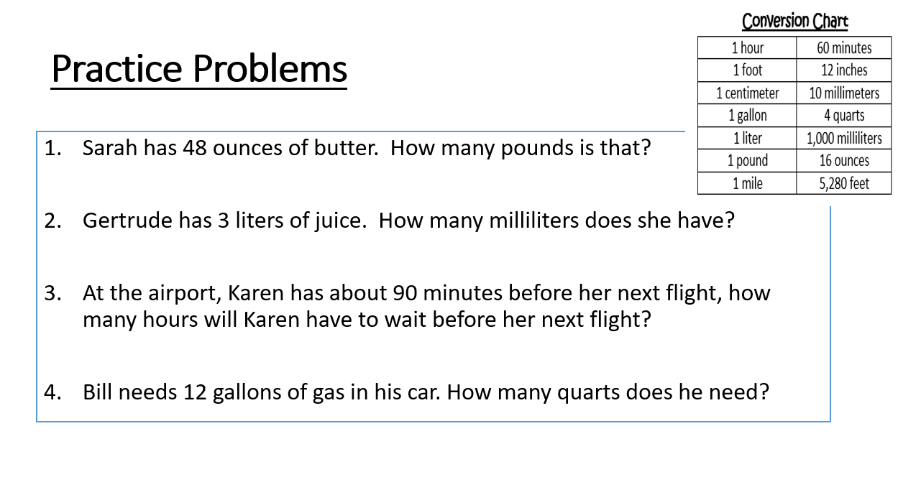**Name: __________________________________**